API DEPLOYMENT

We can do api deployment in

1. [Deploying Flask on Heroku](https://devcenter.heroku.com/articles/getting-started-with-python)
2. [Deploying Flask on Google App Engine](https://cloud.google.com/appengine/docs/standard/python3/runtime)
3. [Deploying Flask on AWS Elastic Beanstalk](https://docs.aws.amazon.com/elasticbeanstalk/latest/dg/create-deploy-python-flask.html)
4. [Deploying on Azure (IIS)](https://docs.microsoft.com/en-us/azure/app-service/containers/how-to-configure-python)
5. [Deploying on PythonAnywhere](https://help.pythonanywhere.com/pages/Flask/)

And first of all, deployment means

* Where other users can also access your api

I am using Heroku method to deploy your api

We can deploy your api’s in 3 stages

1. Prepare app for deployment
2. Setup HEROKU account & installing of Heroku CLI
3. Perform the deployment

And we move to open the visual code

We have to prepare the requirement.txt file

And before that we have to install package name called “g unicorn”

G unicorn 🡪provides as an interface to transfer the http request to actual python

Installing of g unicorn

|  |
| --- |
| Pip install gunicorn |

And then we have to move to create the requirement file

By using this command

|  |
| --- |
| Pip freeze > requirments.txt |

We need know procfile for Heroku

We have to create procfile and then in that procfile we have write this command

|  |
| --- |
| web: gunicorn app:app |

And then we have to move Heroku site and we have login

Firstly, we have to open our command prompt and we have to give this command

Heroku login

Then it will re-direct to your Heroku page and it will show login

* If you already logged in to that account then give your login details
* Otherwise, we have to move signup and give your details

And if logged after then next move to command prompt and type the above command

And after it will say type any alphabet or number

And after typing some alphabet it will re-direct the login page and we have to login into it

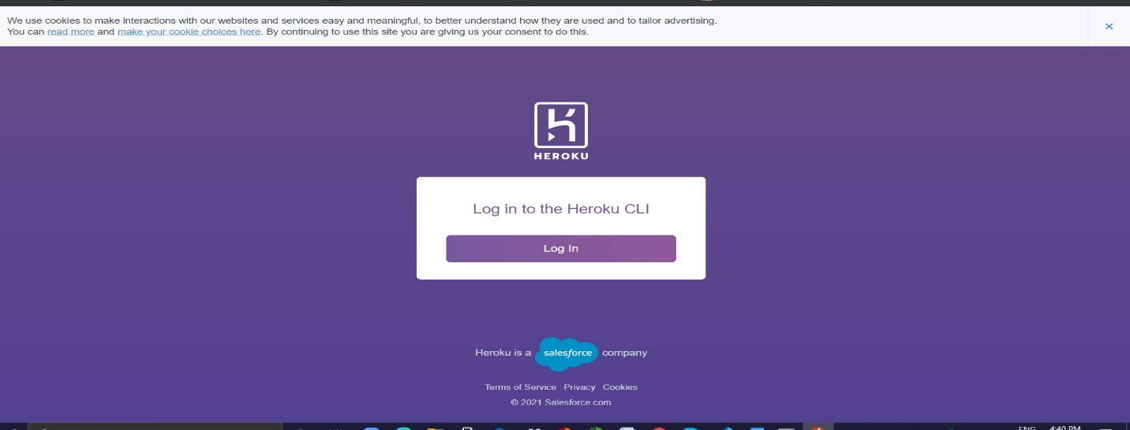

Next in that we have to move to dashboard and we have to create a new app

And then we have to give name to it and click on the submit

We will the this page:

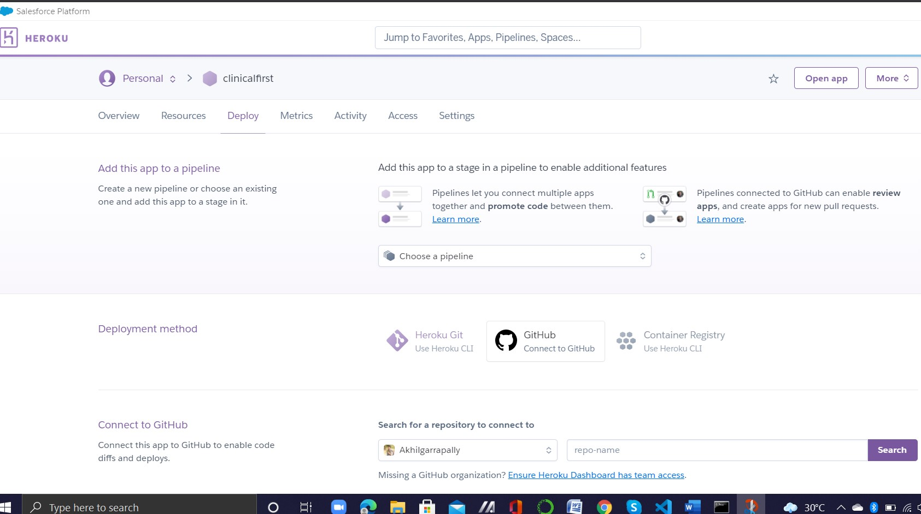

And we have to move to command prompt

* There we have to give the file path
* And after that we have initiate this command

Git init.py

Git –add on

Git commit -m “your wish you can give any name”

And then

Heroku git: remote -a [app name which we had created in Heroku

dashboard]

git push Heroku master

Heroku dashboard will open and, in that dashboard, we have to click on open app

And it will re-direct to another page with URL

So, then copy the URL and test it the postman application